1. **Module 1: Introduction and Learning Objectives**

Learn what Cloud Application development involves from the very beginning. Discover the languages, frameworks, and tools that enable you to create interactive and engaging websites and Cloud Applications, right from the very beginning. In this module, you will learn about the roles of front-end, back-end, and full-stack developers and how they work together on development projects and become familiar with the terminology and skills you will need in your career as a Cloud App developer. It is recommended that learner’s practice outside of the course to become proficient. The labs are intended as an introduction to the basics.   
  
After completing this module, you will be able to:

* Describe what developing a website or Cloud App involves.
* Recognize some of the terminologies that web developers and Cloud App developers use.
* List the skills that Front-end, Back-end, and Full-stack developers need.
* Identify the tools that developers use to develop Cloud Apps.

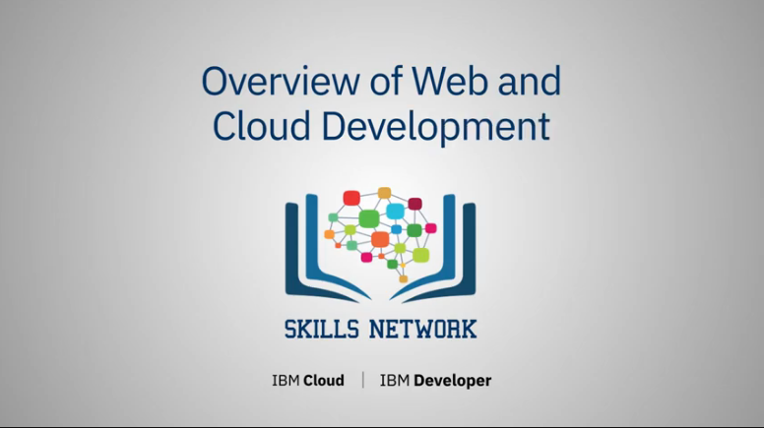

1. **Module 1, Part I: Overview of Web and Cloud Development**

When you’re starting out as a Web Developer, it can be difficult to determine what you need to learn and what order you should learn it in.

Understanding how the websites that you’re already familiar with are constructed and delivered to you is a good starting point.

Let’s review the basics of how you interact with a website.

You launch an internet browser – there are lots available:

Google Chrome, Microsoft Edge, Mozilla Firefox, and Apple Safari are some of the most popular.

The browser has an address bar, into which you enter a URL, like www.IBM.com.

The browser then contacts the server with the name and requests the information that makes up the website.

The server then sends a response, which contains the data that the client requires to display the website.

For most websites, the server will return:

* HTML, which defines the structure of the page, but doesn’t look very attractive.
* CSS, which adds styles and flair to the page and,
* JavaScript, which adds interactivity and dynamic content.

Content displayed by websites can contain elements that are either previously stored on the server (called “static”) or generated each time they are requested by the client (called “dynamic”).

Dynamic elements can involve information coming from other systems and applications, such as databases.

Most websites contain static and dynamic elements to provide the best user experience.

Cloud Applications are similar to Websites in that they request content that a server returns.

Cloud Apps are built to work seamlessly with a Cloud-based back-end infrastructure, Cloud-based data storage and data processing, and other Cloud services, making them very scalable and very resilient.

The environment for building websites and Cloud Applications is divided into two primary areas:

* + The **front-end** deals with everything that happens at the client-side – everything the user can see and interact with.

You can choose to specialize in front-end coding, using HTML, CSS, JavaScript and related frameworks, libraries, and tools.

* + The **back-end** deals with everything that happens on the server before the code and data are sent to the client.

The back-end coding usually handles the logic and functionality that make the website or app work, and the authentication processes that keep data secure.

Back-end developers may also work with relational or noSQL databases, even collaborating with database administrators in bigger projects.

Full-stack developers have skills, knowledge, and experience in both front-end and back-end environments.

Whichever way you choose to specialize, you will need the appropriate tools to help you work.

The first tool most developers add to their resources is a code editor.

Developers also need tools to integrate, build, compile, and debug code.

Integrated Development Environments or IDEs incorporate some of these additional capabilities beyond just code editing and make it easier to build and manage your code.

Good IDEs support multiple languages and integrate with management and storage tools like Git and GitHub.

Other useful features are custom extensions and themes for supporting your working style and environment.

Examples for code editors and IDEs include Sublime Text, Atom, Vim, VS Code, Visual Studio, Eclipse and NetBeans.

In this brief overview, you learned about:

* The basic communication between client and servers,
* How websites are built and displayed,
* Front-end development is about what happens on the client,
* Back-end development is about what happens on the server,
* Full-stack development incudes both front-end and back-end development,
* IDEs will help you create and manage your code.

1. **Module 1, Part II: Learning Front-End Development**

Internet websites offer lots of different services, one of the most popular being online shopping.

When you explore an online shopping website, navigating through pages, choosing different product categories, or comparing products, you are interacting with the front-end of a website.

Let us see how the front-end of a website is developed by front-end developers.

For this, we need to understand how a website is made.

To create a website, web developers usually use Hypertext Markup Language (HTML), Cascading Style Sheets (CSS) and JavaScript. These languages are designed to work in conjunction with each other.

HTML is used to create the physical structure of a website.

The physical structure contains elements such as text, links, images/videos, page dividers and buttons.

The HTML code ensures a proper formatting of all text and image elements so that browsers display the page consistently.

The backend developer codes the structure of the website.

A website is like a house which has only been constructed.

Just like we need interior designers to add style to a space, we need front-end developers to add the necessary glamor and appeal to a website.

When you order products from any website, you realize that the pages have a pleasing font style, attractive colors and are easy to navigate.

Developers use CSS to create stylish websites.

CSS provides front-end developers with a standard method to define, apply, and manage different sets of style characteristics for a website and each of its components.

CSS ensures uniformity in look and feel, style, colors, fonts, designs and layouts.

So, HTML is used to create the structure and CSS is used to design it and make it appealing.

CSS is also used to create websites that have cross browser compatibility which means that they are compatible with multiple browsers and multiple devices such as PC, mobile devices, iPads etc.

Online shopping websites are intuitive, interactive and quick to load. This is where JavaScript comes into the picture.

JavaScript is an object-oriented programming language that is used in conjunction with HTML and CSS to add interactivity to a website.

For example, you use HTML to add a login button to a page, and CSS to style that button.

You then use JavaScript to add log-in functionality to that button.

A new front-end development language is Syntactically Awesome Style Sheets (SAAS).

It is an extension of CSS that is compatible with all versions of CSS.

SAAS enables you to use things like variables, nested rules, and inline imports to keep things organized.

SAAS allows you to create style sheets faster and more easily.

Another language that is being used now is Learner Style Sheets (LESS).

LESS enhances CSS, adding more styles and functions. It is backwards compatible with CSS.

Less.js is a JavaScript tool that converts the LESS styles to CSS styles.

Using all these languages, websites are designed as reactive and responsive.

Reactive or adaptive websites display the version of the website designed for a specific screen size.

For example, a website can provide more information if opened on a PC than when opened on a mobile device.

Responsive design of a website means that it will automatically resize to the device it is being accessed from.

For example, if you open up a products website on your mobile device, it will adapt itself to the small size of the screen and still show you all the features.

A JavaScript framework is an application framework that is written in JavaScript.

Programmers can manipulate the different functions, use them wherever required and can create device responsive applications.

*A few examples of several frameworks being used are:*

* Angular framework is an open-source framework and is being maintained by Google.

Angular frameworks allow websites to render the HTML pages quickly and efficiently.

It has built-in tools for routing and form validation.

* React.js has been developed and maintained by Facebook.

It is a JavaScript library that builds and renders components for a web page. It is not a complete suite of tools. For example, routing is not a part of this framework and will need to be added using a third-party tool.

*React.js only helps build and drop components into a page.*

* Vue.js is maintained by the community and its main focus is the view layer which includes user interface, buttons, and visual components. It is flexible, scalable and integrates well with other frameworks. It is very adaptable – it can be a library, or it can be the framework.

The task of a front-end developer evolves continuously.

The technologies are upgraded constantly and so front-end developers needs to keep upgrading the websites that they create.

The websites that they create should work in multiple browsers, multiple operating systems and multiple devices.

1. **Module 1, Part III: Introducing Application Development Tools**

Welcome to Introducing Application Development Tools.

Getting your Cloud App from the ideas stage to fully formed, written, and deployed is a long process, but there are many tools which will help you along the way.

A cloud application developer’s workbench includes:

* Version Control,
* Libraries, and
* Frameworks.

When many developers are working on the same project, knowing what order changes were made, thereby creating a new version of the source code, becomes overridingly important.

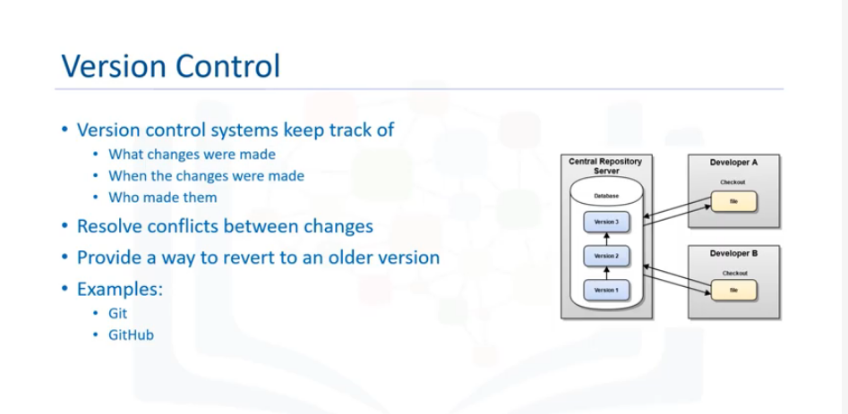

Version control systems keep track of what changes were made when and by whom and resolve any conflicts between changes.

For developing your code version control can be useful even when you are the sole contributor on a project.

Properly used, it can give you a way to revert to an older version of your code if something goes wrong and gives you some basic information about how the code developed over time.

Version control functionality is generally tied to the storage system you are using, which is why a code repository is recommended, even for beginners.

Git and GitHub are extremely popular for source code storage and management. Git stores files in repositories where you can track changes, split code into different branches for more focused development, and then merge them back into the main body of code.

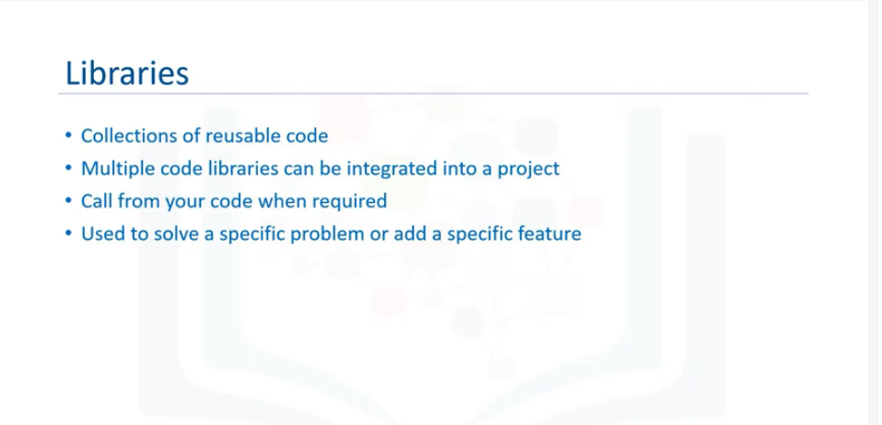

Libraries are collections of code, like standard programs and subroutines, that you can use within your code.

For example, you might want to include a navigational feature, like a carousel – a code library can supply you with the code for that so that you don’t have to spend the time and energy creating one from scratch.

Being able to reuse code in this way makes developing your app much quicker and easier.

Multiple code libraries can be integrated into your existing project.

As you discover a need for a specific function or feature, you can research an appropriate library.

You determine when to call the required method as needed, and control returns to the program flow once the subroutine is finished.

When you use a code library, you are in control.

Code libraries are generally used to solve a specific problem or add a specific feature set.

Either way, there are lots for you to choose from, so do your research.

Here are some examples of code libraries:



* jQuery is a JavaScript library that simplifies Dom manipulation.



* Email-validator is a small library that checks an email address is correctly constructed and valid.



* Apache Commons Proper is a repository of reusable Java components.

Frameworks provide a standard way to build and deploy applications.

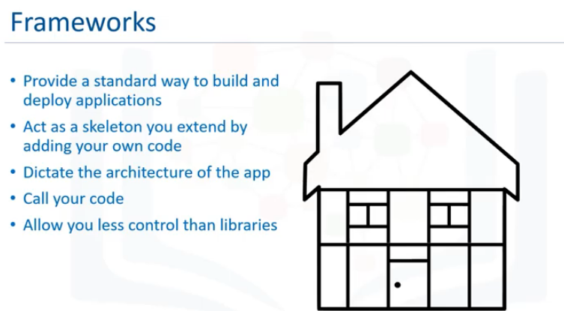

You can think of a framework as being a skeleton that you can extend by adding your own code, providing a scaffold on which to build your apps.

The framework you intend to use must be determined early in your development planning and used right from the beginning.

New frameworks can’t be incorporated into an existing project.

Your chosen framework dictates the architecture of your program and controls the program flow.

The framework determines which subroutines and methods will be called when.

When working with a framework, there is a specific structure that you must follow.

The framework is calling calls on your code, rather than you calling on the framework.

Frameworks are less flexible than libraries, allowing you less control, but they do provide good standardization and can help you create efficient code.

To use an analogy, if you are a carpenter building a house, the framework is the frame that you add to – bricks on the outside, plasterboard on the inside, and so on.

The frame acts as a guide for how the house is constructed.

Here are some examples of frameworks:

* AngularJS is a JavaScript-based framework for dynamic web applications.
* Vue.js is a JavaScript framework focused on the user interface.
* Django is a framework that uses Python for web development.

Frameworks define the workflow that you must follow, unlike libraries, which allow you to call functions as and when required.

When using a framework, it can sometimes feel like you, as a developer, are not in full control of the development process.

This sense of the framework and its predefined workflow controlling the development process is referred to as inversion of control.

Frameworks that have a lot of control are known as opinionated – they have opinions on how their workflow should be used and remove a lot of the decisions you would otherwise have to make about how code is written, the location of files, and even file names.

Frameworks often include their own libraries, which they call when needed.

Inversion of control allows you to create standardized apps, and takes away a lot of the tedious configuration work, so you can focus on the code for your app.

In this last module, you’ve learned about some of the tools that you will utilize in your career as a developer including:

* Version control,
* libraries,
* frameworks

1. **Module 1, Part IV: More Application Development Tools**

Welcome to More Application Development Tools.

Let’s look at some tools which can help you get your app built and deployed:

CI/CD, Build Tools, Packages, and Package Managers.

CI/CD refers to the practices of continuous integration and either continuous delivery or continuous deployment.

CI/CD is a best practice for devops teams enabling developers to deliver frequent changes reliably.

Implemented through a build-automation server, Continuous Integration (CI) ensures that all the code components work together smoothly.

A CI build environment enables you to integrate newly developed code frequently, at least every day, if not every hour, depending on how quickly the project changes.

Continuous delivery (CD) begins where CI ends. The CI process automatically builds and tests your code, then CD deploys all code changes in a build to a testing or staging environment.

A build tool transforms your source code into the binaries needed for installation.

Build tools organize your source code, set compile flags, and manage dependencies.

They are most important in environments where there are many inter-connected projects, with multiple developers contributing to each project.

In these environments it can be very difficult to keep track of what changes were made, in what order, what dependencies exist, and what needs to be incorporated in the next build, so automation is key to keeping everything running smoothly.

Build automation can automate a wide variety of tasks that developers do in their day-to-day activities like:

* + Downloading dependencies.
  + Compiling source code into binary code.
  + Packaging that binary code.
  + Running tests.
  + Deployment to production systems.

You can initiate a build from the command line or from an IDE.

There are two categories of Build Tools widely in use:

1. Build-automation utilities, which generate build artifacts like executables, by compiling and linking source code.
2. Build-automation servers, which execute build-automation utilities on a scheduled or triggered basis.

Some examples of build tools are:

* Webpack – a module bundler for JavaScript
* Babel – a JavaScript compiler

Now that you have your app developed and tested, you’re ready to deploy.

But how does that happen?

The app needs to be simple and trouble free for the user to install, so a commonly used technique is to collect all the necessary files and bundle them together into a package.

Packages are archive files that contain the app files, instructions for installation, and any metadata that you choose.

They have their own metadata too, including the package description, package version, and any dependencies, like other packages that need to be installed beforehand.

Once you have bundled your app into a package, you can use a package manager to distribute it.

Package managers take care of the tasks of finding, installing, maintaining or uninstalling software packages at the user's request.

Package management systems:

* 1. Coordinate with file archivers to extract package archives.
  2. Verify checksums and digital certificates to ensure the integrity and authenticity of the package.
  3. Locate, download, install, or update existing software from a software repository.
  4. Manage dependencies to ensure a package is installed with all packages it requires.

Some commonly used package managers for each of the major platforms are listed here:

* On Linux - Debian Package Management System (DPKG) and Red Hat Package Manager (RPM)
* On Windows - Chocolatey
* On Android - Package Manager
* On MacOS - Homebrew and MacPorts

Any libraries that are used or utility code that is developed as part of the application is managed with the cloud application package managers.

Here are some examples of package managers for popular languages:

* For Node.js/Javascript - npm
* For Java - Gradle and Maven
* For Ruby - RubyGems
* For Python - Pip and Conda

In this video you’ve learned about some of the tools that you will utilize will support you in your career as a developer , including:

* CI/CD, Build Tools, Packages, Package Managers

1. **Module 1, Part V: The Importance of Back-End Development**

Welcome to the importance of back-end development.

A front-end developer creates websites and Cloud applications, using HTML, CSS and JavaScript to create what the user sees and interacts with in the client software.

A back-end developer creates and manages all the resources that are needed to respond to the requests that the user makes through the client.

The back-end developer’s tasks focus on enabling the server infrastructure, or back-end, to process requests, supply data, and provide other services securely.

Front-end and back-end developers must work together very closely.

Each needs to understand the requirements of the solution and how their respective parts will interact before the development process can begin.

Throughout the lifecycle of the website or Cloud app, front-end and back-end developers collaborate to resolve issues and add functionality.

How does the work of a back-end developer affect you as you are browsing the internet or using a Cloud app?

Think about it like this: when you’re shopping online, what happens to the data you enter?

Your login information, your product searches, your payment info?

The back-end processes all these things, and the back-end developers write and maintain the parts of the application that process the inputs.

Let’s think about your experience as you explore an online shopping site and make a purchase.

As you search for products, your search request is submitted to a web application which then retrieves the data from a separate database and serves it back to the client for display.

To facilitate this, a back-end developer must understand the language that the web application uses, how to query the database for the correct data, and how to bring the two together.

Even a simple task like navigating around the site can require the skills of a back-end developer.

Many sites have restricted areas that are only available to users who have an account and have logged in.

User account management, authentication and authorization can be the responsibility of the back-end developer too.

Once you’ve decided what you want to purchase, you must add it to your cart and make a payment.

The purchase process requires you to submit sensitive information, such as your address and credit card number, and the back-end developer must ensure that this data is securely handled and stored.

Front-end client interactions, whether a request for data like an image, accepting input from a user filling out a form, or securing sensitive information like a credit card number all require different services from the back-end server.

Each request needs to interact with the back-end in a different way.

Back-end developers use APIs, routes, and endpoints to process incoming requests:

An **API** is code that works with data, usually using JSON or XML. APIs have set rules and structure.

A **route** is a path to a website or page that the user interacts with.

Routes generally take user input and show results based on the input.

An **endpoint** may be an API or may simply be a path.

When a request from the front-end arrives at the back-end, it is routed to the correct service.

If the backend has an end point defined for the request by using routing, the request will be addressed and replied to.

If the end point is missing, the server returns a 404 error.

Back-end developers must create and maintain this server-side routing.

Along with backend APIs, routes effectively allow the front-end client to plug into the correct socket at the back-end.

APIs provide a mechanism for Cloud apps, mobile apps, and other types of software to access resources from the back-end.

To perform all this back-end development you will need to be familiar with at least one back-end language, and its associated frameworks.

Among the most popular languages today is JavaScript, which was originally designed to run in web browsers, adding extra interactivity and dynamic content to web pages.

JavaScript is also being used on the back-end, with new releases adding server-side functionality.

JavaScript has many frameworks, but two of the most well-known are Node.js and Express.

Python is another popular language; it’s very flexible and easy to learn. Python has wide functionality – it can be used for everything from creating web pages to connecting to a database, to performing data analysis.

Two well-known Python frameworks are Django and Flask.

Back-end developers often work with data and databases, so you will also benefit from learning some SQL.

To help handle requests from databases, back-end developers can use object-relational mapping tools (ORM) to connect to the database and retrieve the correct data.

Although an ORM can hide some of the complexity of querying databases, it’s useful to understand the fundamentals of databases so that you can troubleshoot any issues that arise.

The day-to-day tasks of a back-end developer focus on the behind the scenes functionality that keeps websites, cloud apps and mobile apps up and running.

Back-end development covers a wide range of technologies, from managing user accounts, authentication and authorization to ensuring that sensitive data is stored and transferred securely.

Back-end developers also work with databases, retrieving, processing and storing data as required.

Life for a back-end developer is varied, challenging, and ever changing.

Module 1: Summary

In this module, you learned that:

* Front-end developers work on the parts of the website or app that the user sees and interacts with.
* Back-end developers work on the logic and functionality that keeps the website or app running and responding to users’ inputs.
* Full-stack developers have both sets of skills.
* Front-end developers and back-end developers work closely together.
* Common languages for front-end development include: HTML, CSS, and JavaScript.
* Common languages and frameworks for back-end development include Python, Django, and Flask.
* Frameworks and libraries extend the functionality of coding languages such as JavaScript and Python.